**Enterprise Resource Planning**

**Training User Manual**

**VERSION 12.0.0**

**INVENTORY**

**Index**

|  |  |
| --- | --- |
| **About** | **Page No.** |
| * Create GRN (Against PO) | **03** |
| * Create GRN Detail | **06** |
| * Create GRN Confirm | **07** |
|  |  |
|  |  |
|  |  |

* Create GRN (Against PO)

## Header Entry

|  |  |
| --- | --- |
| **Step 1** | Open System **>** Inventory **>** [Create](http://localhost:8080/zab/login?screen=poadvadjheader&option=Purchase+Advance+Adjustment) GRN |
| **Step 2** | Pick PO number From the side list |
| **Step 3** | Define the Store Code. |
| **Step 3** | Click **Create GRN**. |
| **Result** | GRN will be created against the PO  ** Pick the created GRN to go GRN Header |

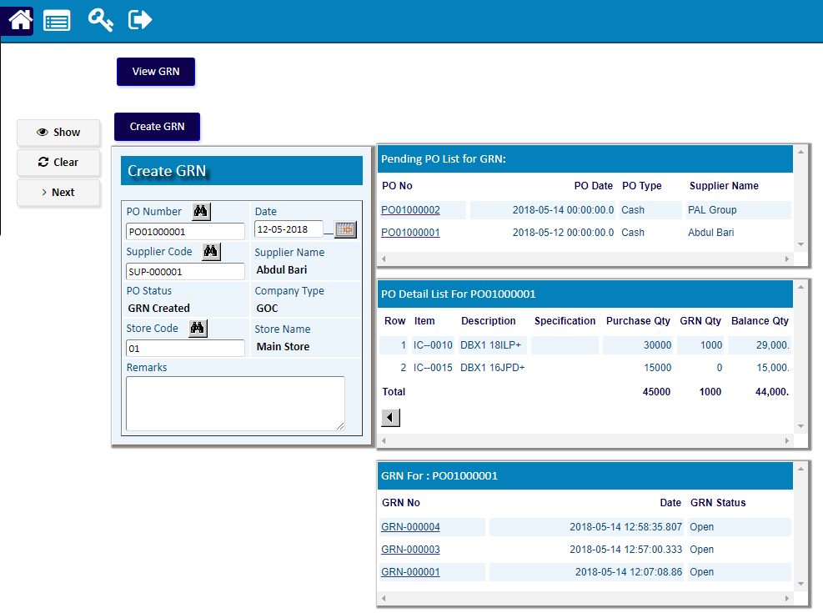

** Pick the created GRN to go GRN Header

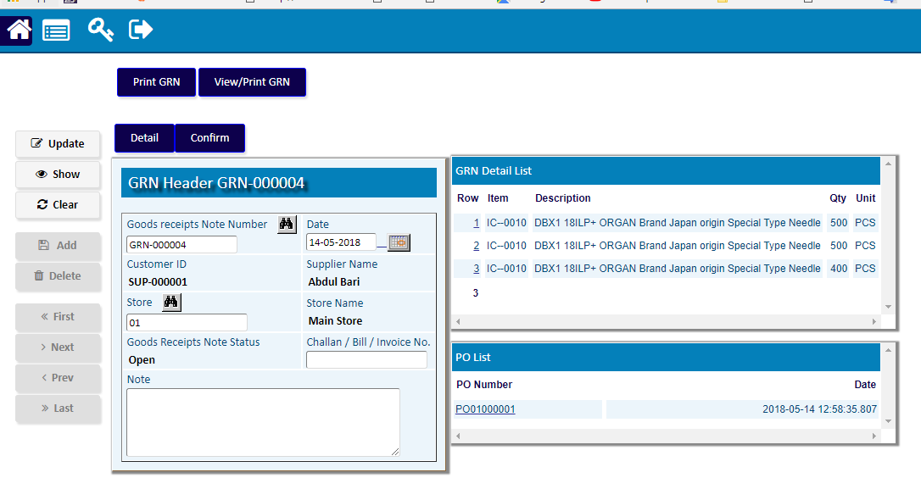

## Detail Entry

|  |  |
| --- | --- |
| **Step 1** | Click **Detail** |
| **Step 2** | Pick Item Code From the side list of PO detail |
| **Step 3** | Fix the Serial / Box type |
| **Step 3** | Write the Quantity Received. |
| **Step 4** | Click **Save** to add the Item record. |
| **Result** | Click **Return** to back to GRN header |

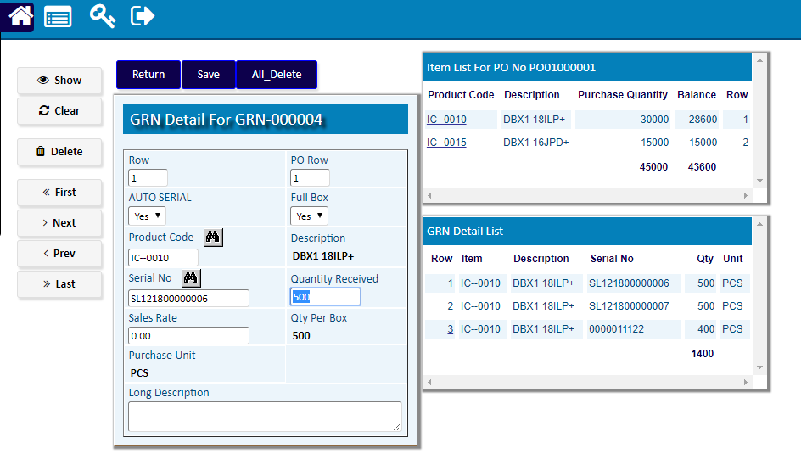

**\*\*)** Click **Confirm** to Confirmthe GRN

